**Attendance Student System**

**1>Detailed Specification**

This is an individual assignment.

You are asked to provide a web application for Attendance Taking & Student Grade Management System at FPT University (I know, FPT already got one, but let assume we are reconstructing it).

You can base on existing sources to develop your design including: fap.fpt.edu.vn, flm.fpt.edu.vn, ...

**Attendance Taking Sub-System**

Every semester, Lecturers and students will receive their schedules for classes. The below figure displays an example of the particular lecture, you can check your own to see the detail schedule for student.

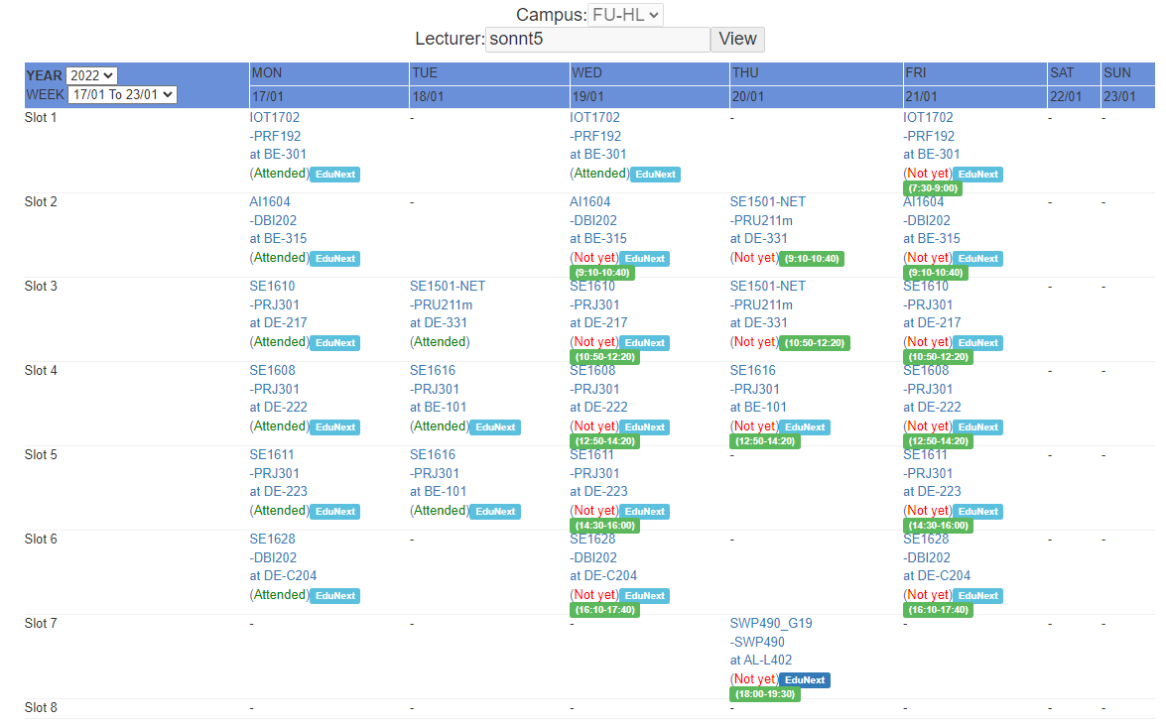

Each class, the lecture going to take attendance for student, all of their absent/present will be recorded.

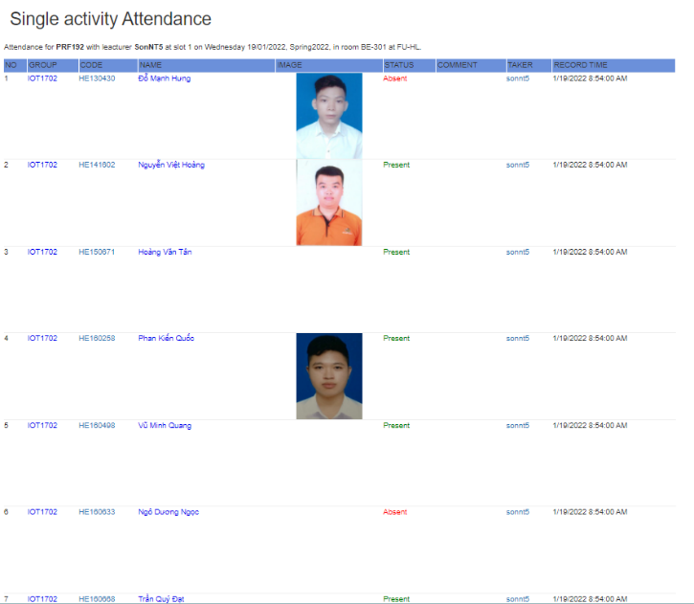

The list of students is grouped by the training department

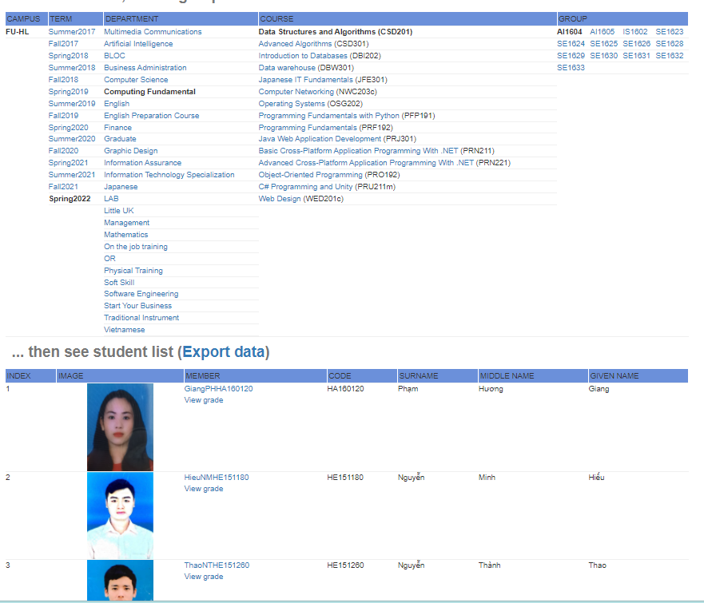

**2>Feature**

**+ Time Table**

**+ Take Attendance**

**+ Status Attendance**

**+ Detail Attendance**

**+ Time Table Study**

**+ Home Lecturer**

**+ Home Student**

**+ Attendance Student**

**3>Model**

**+ Account**

**+ Attendance**

**+ Feature**

**+ Group**

**+ Lecturer**

**+ Role**

**+ Room**

**+ Session**

**+ Student**

**+ Subject**

**+ Time Slot**

